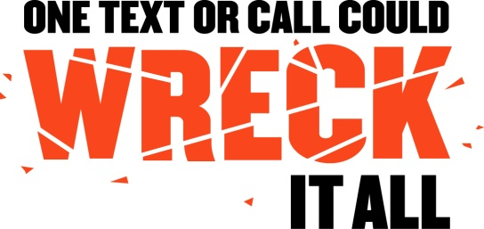

Take the Pledge . . .
The fight to end distracted driving starts with you - right now. Make the commitment to your community and those you love to drive phone-free today.
Distracted driving kills & injures thousands of people each year!
On behalf of my family, friends and myself, and those whom I share the roads with, I PLEDGE:
- To never text while I am driving;
- To use only hands-free calling if I need to speak on the phone while I am driving;
- Be a good passenger & speak out if the driver is distracted;
- Encourage my friends and family to drive phone-free; and
- To be a good example of a safe driver.

SIGNATURE: _______________________________________

DATE: _____________________

Garruto & Calabria, Attorneys at Law - 609 Franklin Ave., Nutley, NJ 973.661.4455 - www.garrutolaw.com

